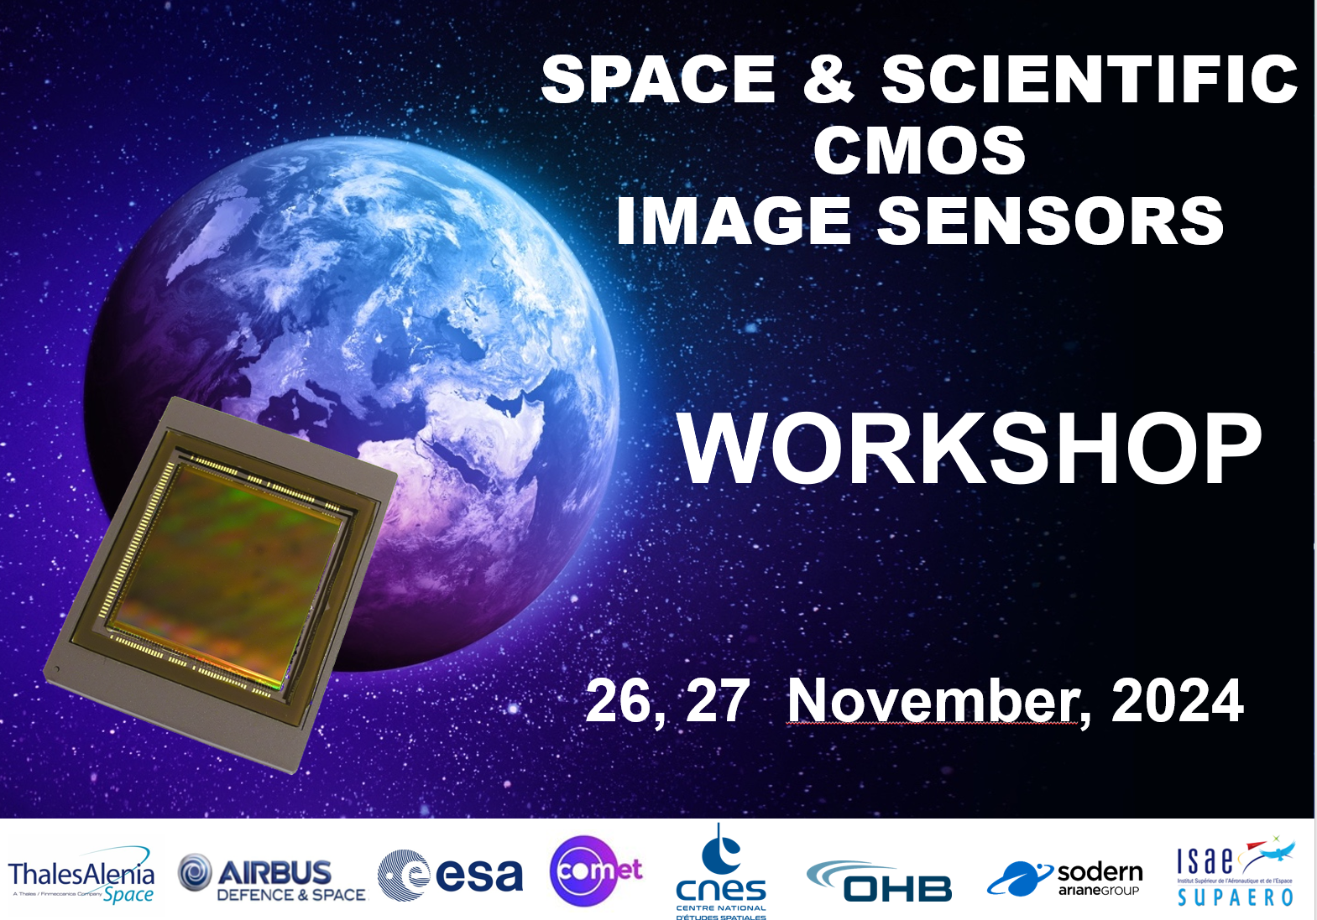

DIAGORA
Centre de Congrès et d'Exposition. 150, rue Pierre Gilles de Gennes
31670 TOULOUSE – LABEGE



SLIDES

Wednesday 27th November

 | Author & Title
09:30 | TUTORIAL
 | The Timepix Family of Hybrid Pixel Detectors and Applications in Measurement of Space Radiation
 | R. Ballabriga, M. Campbell, , X. Llopart – CERN, Geneva, Switzerland
 | C. Granja - ADVACAM, Prague, Czech Republic
SESSION | CMOS for Time stamping
 | Chair: O. Marcelot ISAE-SUPAERO
10:20 | Development of a LIDAR Receiver Unit: LIROC- PICOTDC
T. Saleem, S. Ahmad, A. Hadar, F. Perez, J. Fleury – WEEROC, Villebon sur Yvette, France
A. Panglosse, A. Materne, CNES, Toulouse, France
10:40 | FLAMES: A Flash LidAr iMagE Sensor chip for Rendez-vous and Landing applications
J. Vermeiren, V. Schuddinck, G. Cai, B. De Schepper, B. Dierick, J. Basteleus – Caeleste, Mechelen Belgium
K. Haugholt, H. Torring, B. Nossum – SINTEF, Norway
M. Somann – ESA-ESTEC, The Netherlands
11:00 | Towards Characterizing Spatial Contrast Transfer in Event-Based Cameras
 | L. Baehr, D. Joubert, F. Le Goff – Prophesee, France
 | L. Baehr, M. Estribeau, V. Goiffon – ISAE-SUPAERO, Toulouse, France
SESSION | Architectures
 | Chair: S. Demiguel Thales Alenia Space
11:50 | Design and characterisation of a full-frame low-noise HDR 8μm, 12Mpixel, 34fps CMOS image sensor for industrial, medical, space and scientific applications
M. Sannino, C. Bauza-Alcover, A. Font-Garcia, R. Gifreu-Pons, M. Gargallo, M. Giulioni, K. Latif Akhtar,O. Llados-Cos, A. Molla-Garcia, V. Palmero-Arans, A. Scott, R. Turchetta, A. Bofill-Petit – IMASENIC, Barcelona, Spain
D. Uzbelger Feldman – Real Time Imaging Technologies, Charlotte USA
E. Simons – Blur Product Development, Cary, USA
A. Birman – Tower Semiconductor, Migdal Haemek, Israel
12:10 | CMOS TDI Detectors for High Resolution Imaging
 | S. Sanjeevi, V. Arkesteijn, L. Wu, C. Hong, HJ. Lee, G. Rodrigues, M. Miethig, R. Ghannoum, P. Donegan, S. Kullar – Teledyne DALSA, Waterloo, CANADA
12:30 | Infrared FPA Readout System with the NIRCA MkII ASIC
 | A.Fagerland Haavik, T. Ostmoe, A. Hasanbegovic, D. Meier, B. Samadpoor Rikan, T. Nesjo, HK. Otnes Berge, A. Dadashi, S. Azman, J. Talebi, JE. Holter, P. Oya, G. Maehlum – IDEAS, Oslo, Norway
12:50 | 5 μm Pixel and Column ADC for 1 MGy Radiation Tolerant CMOS Image Sensor
 | I. Hafizh, P. Santos, P. Leroux, and G. Meynants – KU Leuven, Belgium
SESSION | CMOS for Scientific Applications
 | Chair: A. Vriet Sodern
14:20 | CMOS X-ray Sensors for Future Space Astronomy and Planetary Science
A.Holland, T. Buggey, C. Crews, D. Hall, J. Ivory, C. Townsend-Rose, K. Stefanov -
Centre for Electronic Imaging, The Open University, UK
14:40 | CMOS Sensors for Scientific Imaging at the CEI
K. Stefanov, T. Buggey, C. Crews, D. Hall, A. Holland, J. Ivory, M. Patel, M. Prest, J. Skottfelt, ,
P. Smith - Centre for Electronic Imaging, The Open University, UK
15:00 | The ARCADIA Depleted Monolithic Active Pixel: X-ray characterization and imaging applications
S. Ciarlantini, C. Bonini, D. Chiappara, P. Giubilato, S. Mattiazzo, C.
Pantouvakis, M. Rignanese, and A. Zingaretti – University of Padova, Italy - Istituto Nazionale di Fisica Nucleare (INFN), Padova section, Italy
15:20 | Fast & low read noise CMOS camera for planetary science and astrophysics
 | MM. Roth - Deutsches Zentrum für Astrophysik (DZA), Görlitz Leibniz-Institut für Astrophysik Potsdam (AIP) Universität Potsdam, Germany

