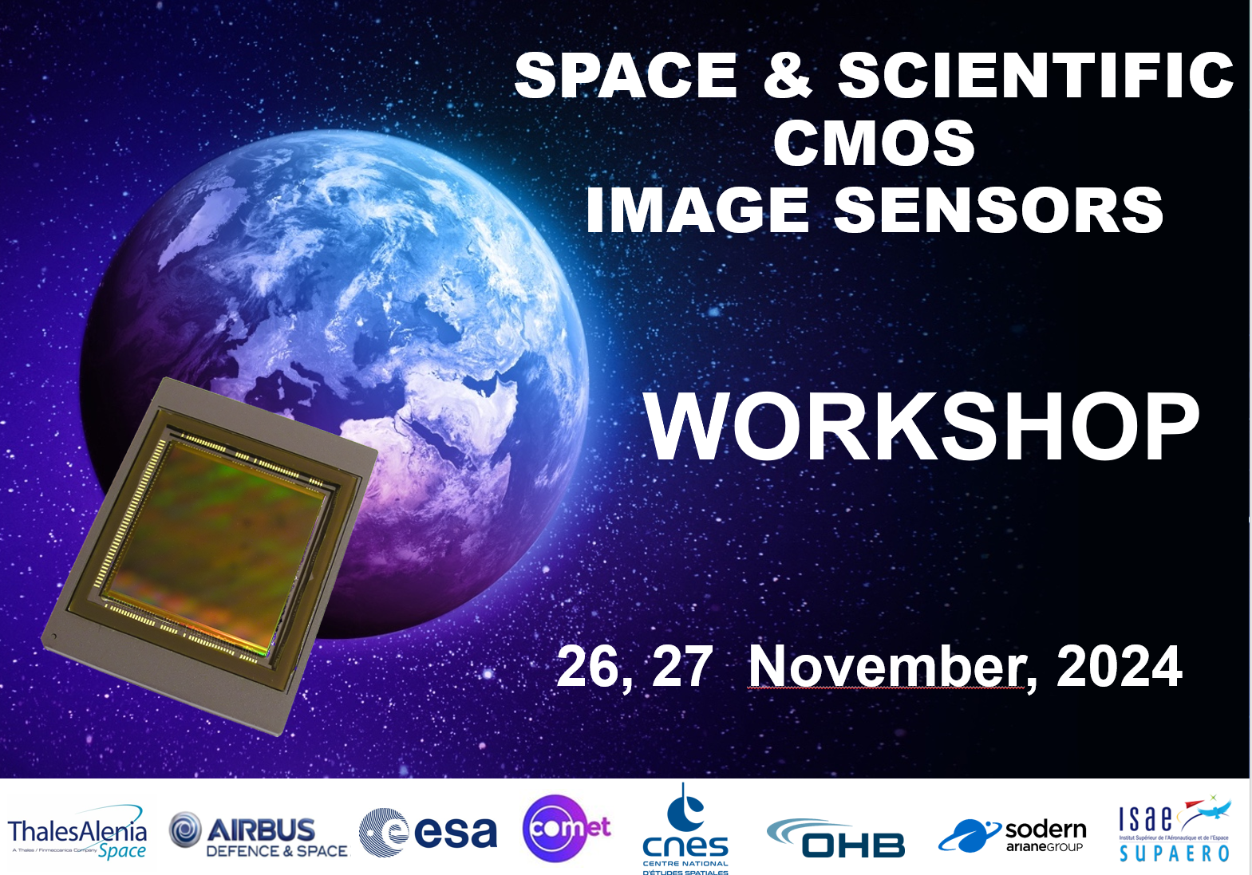

DIAGORA
Centre de Congrès et d'Exposition. 150, rue Pierre Gilles de Gennes
31670 TOULOUSE – LABEGE



SLIDES

Tuesday 26th November

 | Author and Title
10:00 | TUTORIAL
 | Photon-number-resolving image sensors
 | L. Durdevic – Hamamatsu Photonics, Paris - France
SESSION | Low Flux
 | Chair: N. Nelms ESA
10:50 | Analysis of Temporal Noise of 1×2 Shared Pixel Architecture for On-Chip Averaging and Summing
 | H. Uppal, A. Kumar, S. Gopalakrishna, R. Ispasoiu – Onsemi, Intelligent Sensing Group
11:10 | Radiation Effects in Quanta Image Sensors
J. Krynski, A. Neyret, A. Le Roch, V. Goiffon – ISAE-SUPAERO, Toulouse, France
V. Bernard, V. Lalucaa, A. Materne, C. Virmontois – CNES, Toulouse, France
SESSION | Radiations
 | Chair: S. Rizzolo Airbus D&S
11:30 | Radiation test results on a large COTS CMOS Global Shutter Image sensor
A. Materne, C. Virmontois, JP. Millerioux, R. Ecoffet – CNES , Toulouse, France
A. Maillard - Astek, Toulouse, France
L. Pelissier – Expleo Group, Toulouse, France
V. Chazal, Thales Six GTS, Toulouse, France
13:40 | In-Flight Hot Pixels and Random Telegraph Signal in Aeolus Accumulation CCDs Operated at Low Temperature
A. Plocina, V. Goiffon, O. Marcelot, A. Salih Alj, and A. Antonsanti – ISAE-SUPAERO, Toulouse, Fr
D.Marchais, O. Saint-Pe, S. Rizzolo - AIRBUS D&S, Toulouse, France
J. Pratlong, R. Bell - Teledyne e2v, Chelmsford, UK
14:00 | TNID and Heavy Ions Irradiations Study on the GigaPyx COTS CIS sensor
J. Michelot, M. Douix, JB. Mancini, M. Guillon – Pyxalis, Moirans, France
K. Melendez, C. Ravinet, M. Jouans, G. Estaves, R. Marec, S. Demiguel – Thales Alenia Space, Cannes, France
A. Materne, C. Virmontois - CNES, Toulouse, France
14 :20 | Displacement Damage Induced Dark Current and  Random Telegraph Signal in P-Type Deep-Trench Pinned Photogates
A. Antonsanti, A. Salih Alj, A. Le Roch, V. Goiffon- ISAE-SUPAERO, Toulouse Fr
V. Malherbe, P. Roche, A. Tournier – STmicroelectronics, Crolles, France
L.D. Ryder, JM. Lauenstein - NASA GSFC, USA
C. Virmontois – CNES, Toulouse, France
14 :40 | Displacement Damage Effects on a CDTI-based CCD-on-CMOS: Dark Current and Charge Transfer Inefficiency
A. Salih Alj, A. Antonsanti, A. Le Roch, P. Magnan, V. Goiffon – ISAE-SUPAERO, Toulouse, France
P. Touron, F. Roy, A. Tournier – Stmicroelectronics, Crolles, France
S. Demiguel – Thales Alenia Space, Cannes, France
J. Michelot – Pyxalis, Moirans, France
V. Lalucaa, C. Virmontois, CNES, Toulouse, France
15 :00 | Radiation tolerant event-based asynchronous image sensor
P. Adamiec, E. Cordero Garrido – ALTER TECHNOLOGY, Tres Cantos, SPAIN
J.A. Leñero, R. Gómez Merchán, R. del la Rosa Vidal - Institute of Microelectronics of Seville (IMSE-CNM), CSIC-Universidad de Sevilla, Seville, Spain.
SESSION | Technology Developments
 | Chair: K. Minoglou ESA
15:50 | Enhanced optical filter technologies for compact multi-mode spectral imaging payloads for earth observation
 | B. Delauré, B.Geelen, K. Tack, W. Charle – IMEC, Leuven, Belgium
16:10 | Process of linear variable filter designed for compact imaging spectrometer for space observatory
C. Jamin, A. Arribehaute, JP. Nieto - Univ. Grenoble Alpes, CEA, Leti, Grenoble, France
A. Carcenac, S. Gousset, E. Le Coarer - Institut de Planétologie et d’Astrophysique de Grenoble, Saint-Martin-d’Hères, France,
16:30 | Recent Multispectral Sensors Developments for Space Applications
 | S. Tisserand, T. Berthou, M. Hubert, V. Sauget, S. Gautier, A. Faiola, B. David – SILIOS Technologies, Peynier, France
16 :50 | Multispectral Cameras for Moon Rover
J. Bezine, MC. Vassal, W. Durand-Mouallem – 3DPlus, Buc, France
JM. Belloir, C. Virmontois - CNES Toulouse, France
S. Tisserand, M. Hubert, S. Gautier, V. Sauget – SILIOS Technologies , Peynier, France
K. Tack, B. Delaure, W. Charle - IMEC, Leuven, Belgium
R. Ligot, JL. Dewandel – LAMBDA-X, Nivelles, Belgium
LS. How – Adveotec, Evry Courcouronnes, France
17 :10 | Teledyne e2v technology developments: CIS120, CIS220 (HiRho) and CIS300 (Large Area CMOS) performance results
 | G. Tsiolis – Teledyne e2v, Chelmsford, UK
17:30 | A monolithic thin-film image sensor with lead sulfide quantum  dots coated on CMOS silicon readout for wide-spectral imaging
CM. Zhang, R. Quaglia, P. Blanca Cruz, PF. Ruedi - CSEM, Neuchatel, 2002, Switzerland
A.Shulga, V. Goossens – QDI Systems, Groningen, The Netherlands
A. Al-Haj Husain, B. Stadlinger - Clinic of Cranio-Maxillofacial and Oral Surgery, Center of Dental Medicine, University of Zurich, Switzerland

